# Lab_08

**Exercise for Date**

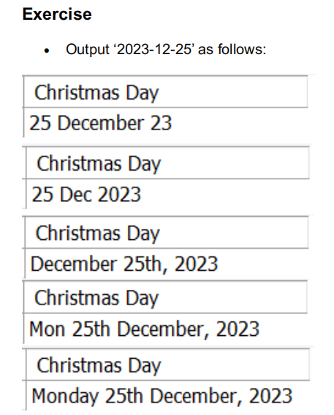

Solution:

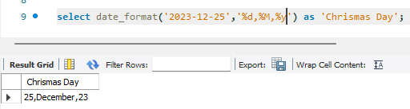

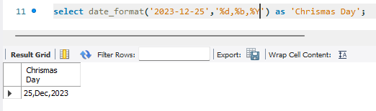

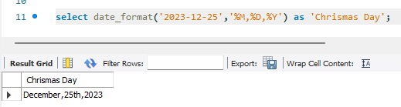

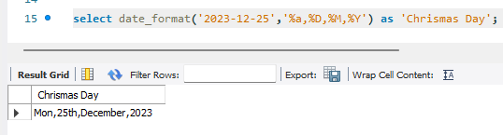

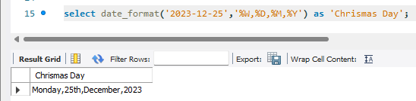

**Exercise Insert**

**Exercise1:**

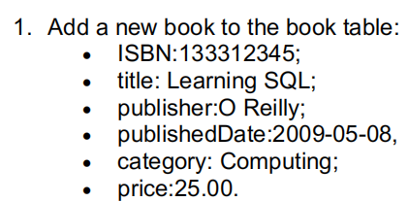

**Solution :**

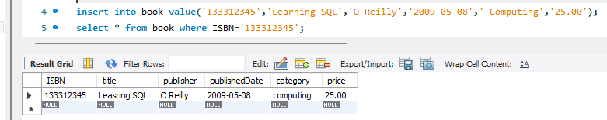

**Exercise2:**



**Solution:**

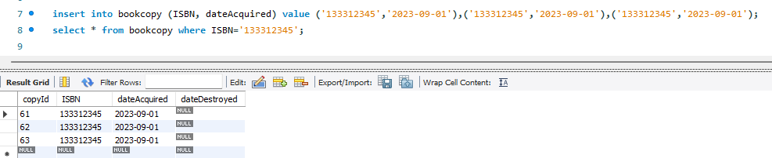

**Exercise3:**



**Solution:**

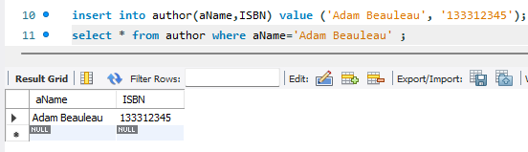

**Exercise4:**



**Solution:**



**Exercise for update**

**Exercise:**

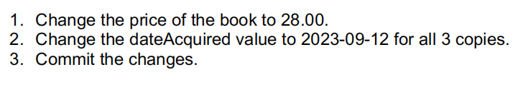

**Solution for 1:**

Code: *update book*

*set price ='28.00'*

*where ISBN='133312345';*

Output:

**Solution for 2:**

Code: *update bookcopy*

*set dateAcquired ='2023-09-12'*

*where ISBN='133312345';*

Output:



**Solution for 3:**

Code:*commit;*

Output:



**Exercise for delete:**

**Exercise:**

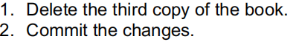

**Solution for 1:**

CODE: *delete from bookcopy where ISBN ='133312345';*

Output:

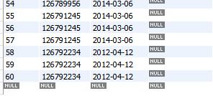

Solution for 2:

Code:  *commit;*

Output:

